**Question 7 answers**

In order to change the M/D/1 simulator to M/D/1/K queue simulator, only three very minor changes were required.

1. Additional input parsing code was added to set the buffer size to K
2. Add a simple if statement to check if the buffer is full before adding a packet
3. Adding a counter to keep track of number of lost packets

The new variables introduced were

* bufferSize = used to keep track of the size of the buffer and check if the buffer is full or not
* packetsDropped, packetsAdded = used to keep track of total number of packets generated and number of dropped packets

**Question 8 answers**

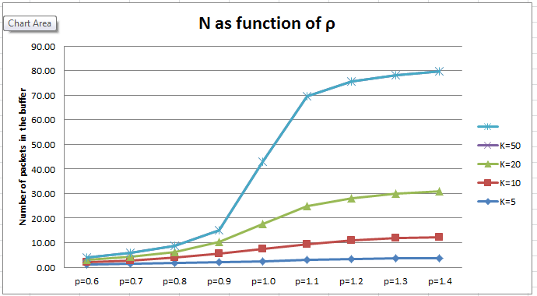

This graph shows the average number of packets in the buffer for 0.5 < ρ < 1.5, step size 0.1. The number of packets in the buffer increases as the ρ increases because larger ρ value means larger service time required to serve each packet.

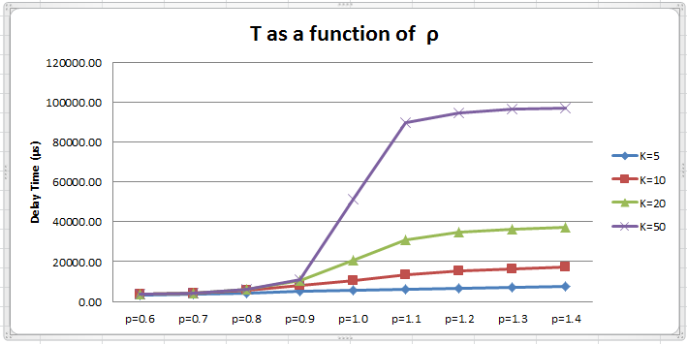

This graph shows the average delay time of packets in the buffer for 0.5 < ρ < 1.5, step size 0.1. The average delay time of packets in the buffer increased as the ρ increases because larger ρ value means larger service time required to serve each packet. Because more time was require for packets to leave the server at higher ρ value, packets had to wait for longer time to be served. This result agrees with the results displayed in the graph which shows the number of packets in the buffer.

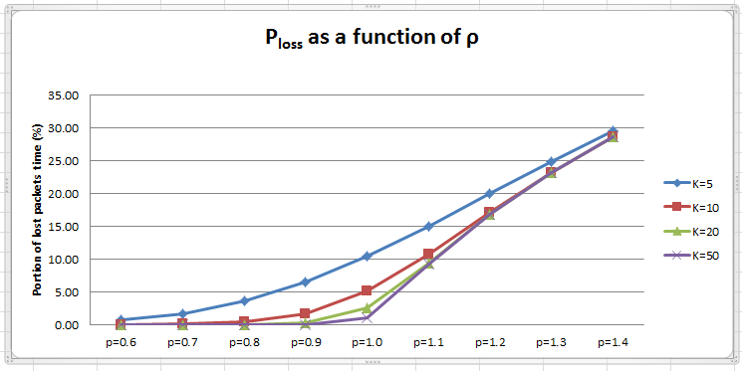

This graph shows the percentage of packets lost for 0.5 < ρ < 1.5, with step size 0.1. As mentioned before, larger ρ means more server time is required for packets to be served, which implies that the average size of the buffer goes up. Due to this effect, the buffer will be filled up more often at higher ρ values, and higher numbers of packets were lost at higher ρ values.

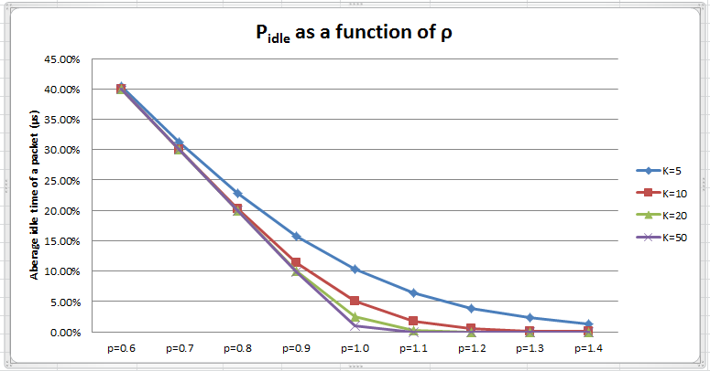

This graph shows the average idle time as a percent of total runtime for 0.5 < ρ < 1.5, with step size 0.1. In this graph it can be observed that the proportion of run time that the server was idle for is relatively high at low ρ values while the idle time eventually decreased to zero for all K values. This is because since there are more packets in the buffer at higher ρ values, there are more packets waiting to be served by the server, hence there is always a packet being pushed into the server.

When ρ was increased to 5, the PLoss rate was increased to 80%. This is because the time required to serve an individual packet is very long, and the buffer gets full very quickly. Because the buffer is full for most of the execution time, majority of arriving packets were dropped.